**ABSTRACT**

A great variety of different fruits have been reported to cause allergic reactions. Since fruits often contain allergenic proteins, fruit allergic individuals may display different reactions to the same fruit. Fruit allergy is frequently observed as local reactions in the oral cavity (oral allergy syndrome). These can occur only minutes after consumption of the respective food and itching and swelling of the mouth, lips and throat are commonly observed. Often mild, these symptoms can be accompanied by skin reactions, asthma and rhinitis. Severe reactions such as cardiovascular symptoms and anaphylaxis can also be experienced by some individuals.

Avoiding plant allergens are quite hard as they comprise major part of our basic diet, a better knowledge about these allergens will prove to be quite helpful. In this project, common fruits consumed in India are taken and epitope mapping of common allergenic proteins in them is done.

**INTRODUCTION**

Plant allergens are one of the most allergenic substances and are quite hard to avoid. Food allergy constitutes adverse immune response against food proteins that are generally harmless. From objectively confirmed results, approximately 5-8% children and 2-3% adults suffer from fruit allergy (1, 2, 3).

Many commonly consumed fruits are associated with food allergy. The reported food allergic reactions are frequently observed to be associated with oral allergy syndrome (OAS) conjoined with pollen-fruit-vegetable syndrome, triggered upon consumption of raw vegetables or fresh fruits. This is most commonly attributed to cross-reacting, homologous proteins found in plant foods. Since, conserved proteins and distinct epitopes of proteins are found throughout the plant kingdom, expression of homologous proteins in plant food is not surprising (5, 6).

Pollen-food syndrome has been associated with specific plants. One of them is birch-fruit-vegetable syndrome, caused by plants belonging to Rosaceae family, such as apple, pear, peach and almond. The most common allergic fruits that are centre of current research on allergy include apple, peach, kiwi, musk melon, grape, cherry, strawberry, banana, mango and pomegranate. Some rare tropical fruits that can also cause highly allergic reactions in some cases are orange, lychee, mulberry, pineapple (4).

Fruits that are commonly consumed in India are taken as the subject for this project and epitope mapping of common allergenic proteins in them is also done.

**MATERIALS AND MATHODS**

* **Sample selection-** Fruits that are commonly consumed in the Indian subcontinent are selected as sample in the project. The fruits that are selected are listed below:

1. Apple (*Malus domestica*)

2. Banana (*Musa acuminata*)

3. Pear (*Pyrus communis*)

4. Sweet cherry (*Prunus avium*)

5. Peach (*Prunus persica*)

6. Pineapple (*Ananas comosus*)

7. Peanut (*Arachis hypogaea*)

8. Sweet orange (*Citrus sinensis*)

9. Almond (*Prunus dulcis*)

10. Strawberry (*Fragaria ananassa*)

11. Carrot (*Daucus carota*)

12. Capsicum (*Capsicum annuum*)

13. Tomato (*Solanum lycopersicum*)

14. English walnut (*Juglans regia*)

15. Pistachio (*Pistacia vera*)

16. Cashew (*Anacardium occidentale*)

17. Grape (*Vitis vinifera*)

* **Selection of allergenic proteins-** A number of proteins are found in the above selected fruits that have shown allergic properties. The major proteins that cause allergies are selected for our project. They are listed below:
* **Profilin**
* **Thaumatin-like protein**
* **Nonspecific lipid-transfer protein**
* **Pathogenesis-related protein**
* **2S albumin**
* **Sequence Retrieval-**The sequences of these proteins for particular fruits are collected from **UniProt** database.

|  |  |  |  |  |  |
| --- | --- | --- | --- | --- | --- |
| **SOURCE NAME** | | **ALLERGEN NAME** | **PROTEIN FAMILY** | **UNIPROT ACCESSION NO.** | |
| APPLE | | Mal d3 | Prolamin super family (nsLTP) | Q5J026 | |
| Mal d 4 | Profilin | Q9XF42 | |
| Mal d 1 | Bet v 1 family(PR-10) | P43211 | |
| [Mal d 2](http://www.allergen.org/viewallergen.php?aid=426) | Thaumatin-like protein | Q9FSG7 | |
| ALMOND | | Pru du3 | Prolamin super family (nsLTP) | C0L0I5 | |
| [Pru du 4](http://www.allergen.org/viewallergen.php?aid=555) | Profilin | Q8GSL5 | |
| BANANA | | Mus a3 | Prolamin super family (nsLTP) | P86333 | |
| [Mus a 1](http://www.allergen.org/viewallergen.php?aid=445) | Profilin | Q94JN3 | |
| Mus a 4 | Thaumatin-like protein |  | |
| CAPSICUM | | [Cap a 2](http://www.allergen.org/viewallergen.php?aid=181) | Profilin | Q93YI9 | |
| Cap a 1 | Thaumatin-like protein | Q9ARG0 | |
| CARROT | | Dau c 4 | Profilin | Q8SAE6 | |
| Dau c 1 | Bet v 1 family(PR-10) | O04298 | |
| CASHEW | | Ana o 3 | Prolamin super family (2s albumin) | Q8H2B8 | |
| ENGLISH WALNUT | | Jug r 1 | Prolamin super family (2s albumin) | P93198 | |
| GRAPE | | Vit v1.0101 | Prolamin super family (nsLTP) | Q850K5 | |
| PEAR | | Pyr c3 | Prolamin super family (nsLTP) | Q9M5X6 | |
| [Pyr c 4](http://www.allergen.org/viewallergen.php?aid=564) | Profilin | Q9XF38 | |
| Pyr c 1 | Bet v 1 family(PR-10) | O65200 | |
| PEACH | | Pru p3 | Prolamin super family (nsLTP) | P81402 | |
| [Pru p 4](http://www.allergen.org/viewallergen.php?aid=559) | Profilin | Q2I6V8 | |
| [Pru p 2](http://www.allergen.org/viewallergen.php?aid=664) | Thaumatin-like protein | B6CQT7 | |
| PEANUT | | Ara h 6 | Prolamin super family (2s albumin) | Q647G9 |  |
| Ara h9 | Prolamin super family (nsLTP) | B6CEX8 |  |
| [Ara h 5](http://www.allergen.org/viewallergen.php?aid=81) | Profilin | Q9SQI9 |  |
| Ara h8 | Bet v 1 family(PR-10) | Q6VT83 |  |
| PINEAPPLE | | Ana c 1 | Profilin | Q94JN2 |  |
| PISTACHIO | | Pis v 1 | Prolamin super family (2s albumin) | B7P072 | |
| STRAWBERRY |  | Fra a3 | Prolamin super family (nsLTP) | Q8VX12 | |
| [Fra a 4](http://www.allergen.org/viewallergen.php?aid=330) | Profilin | P0C0Y3 | |
| Fra a 1 | Bet v 1 family(PR-10) | Q5ULZ4 | |
| SWEETE CHERRY |  | Pru av3 | Prolamin super family (nsLTP) | Q9M5X8 | |
| Pru av 4 | Profilin | Q9XF39 | |
| Pru av 1 | Bet v 1 family(PR-10) | O24248 | |
| [Pru av 2](http://www.allergen.org/viewallergen.php?aid=550) | Thaumatin-like protein | P50694 | |
| SWEET ORANGE |  | Cit s3 | Prolamin super family (nsLTP) | P84161 | |
| [Cit s 2](http://www.allergen.org/viewallergen.php?aid=211) | Profilin | P84177 | |
| TOMATO |  | Sola l3 | Prolamin super family (nsLTP) | P93224 | |
| [Sola l 1](http://www.allergen.org/viewallergen.php?aid=422) | Profilin | Q93YG7 | |
| Sola l 4 | Bet v 1 family(PR-10) | K4CWC5 | |

* **MULTIPLE SEQUENCE ALINGNMENT-** A multiple sequence alignment (MSA) is a [sequence alignment](https://en.wikipedia.org/wiki/Sequence_alignment) of three or more [biological sequences](https://en.wikipedia.org/wiki/Biological_sequence), generally [protein](https://en.wikipedia.org/wiki/Protein), [DNA](https://en.wikipedia.org/wiki/DNA), or [RNA](https://en.wikipedia.org/wiki/RNA). In many cases, the input set of query sequences are assumed to have an [evolutionary](https://en.wikipedia.org/wiki/Evolutionary) relationship by which they share a linkage and are descended from a common ancestor. From the resulting MSA, sequence [homology](https://en.wikipedia.org/wiki/Homology_(biology)) can be inferred and [phylogenetic analysis](https://en.wikipedia.org/wiki/Molecular_phylogeny) can be conducted to assess the sequences' shared evolutionary origins.

In our project, we used T-Coffee to perform multiple sequence alignment of chosen protein of selected foods.

* **EPITOPE PREDICTION-** An epitope, also known as antigenic determinant, is the part of an antigen that is recognized by the immune system, by the antibodies, B cells or T cells. Specifically, the epitope is the piece of the antigen to which an antibody binds.

In our project, we used ABCpred and Bcepred for the prediction of epitope in an antigen sequence.

* **MODELLING OF THREE DIMENSIONAL PROTEIN STRUCTURE-** In our project, we used SWISS-MODEL to perform homology modelling of three dimensional protein structures. Homology modelling methods make use of experimental protein structures (“templates”) to build models of proteins (“targets”).
* **EPITOPE MAPPING-** Epitope mapping is the experimental process of identifying the binding site or “epitope”, of an antibody on its target antigen (usually, on a protein).

In our project, we used the PyMOL software to perform epitope mapping of chosen protein of the selected fruits.

**RESULT AND DISCUSSION**

* **The graph showing prevalence of our selected food with respect to prevalence of common tested food is prepared using the AllFam database.**

From the graph, we can see that maximum samples contain profilin so all the further work is done for this group.

* **The result of T-Coffee software that was used to perform multiple sequence alignment of profilin present in selected foods.**

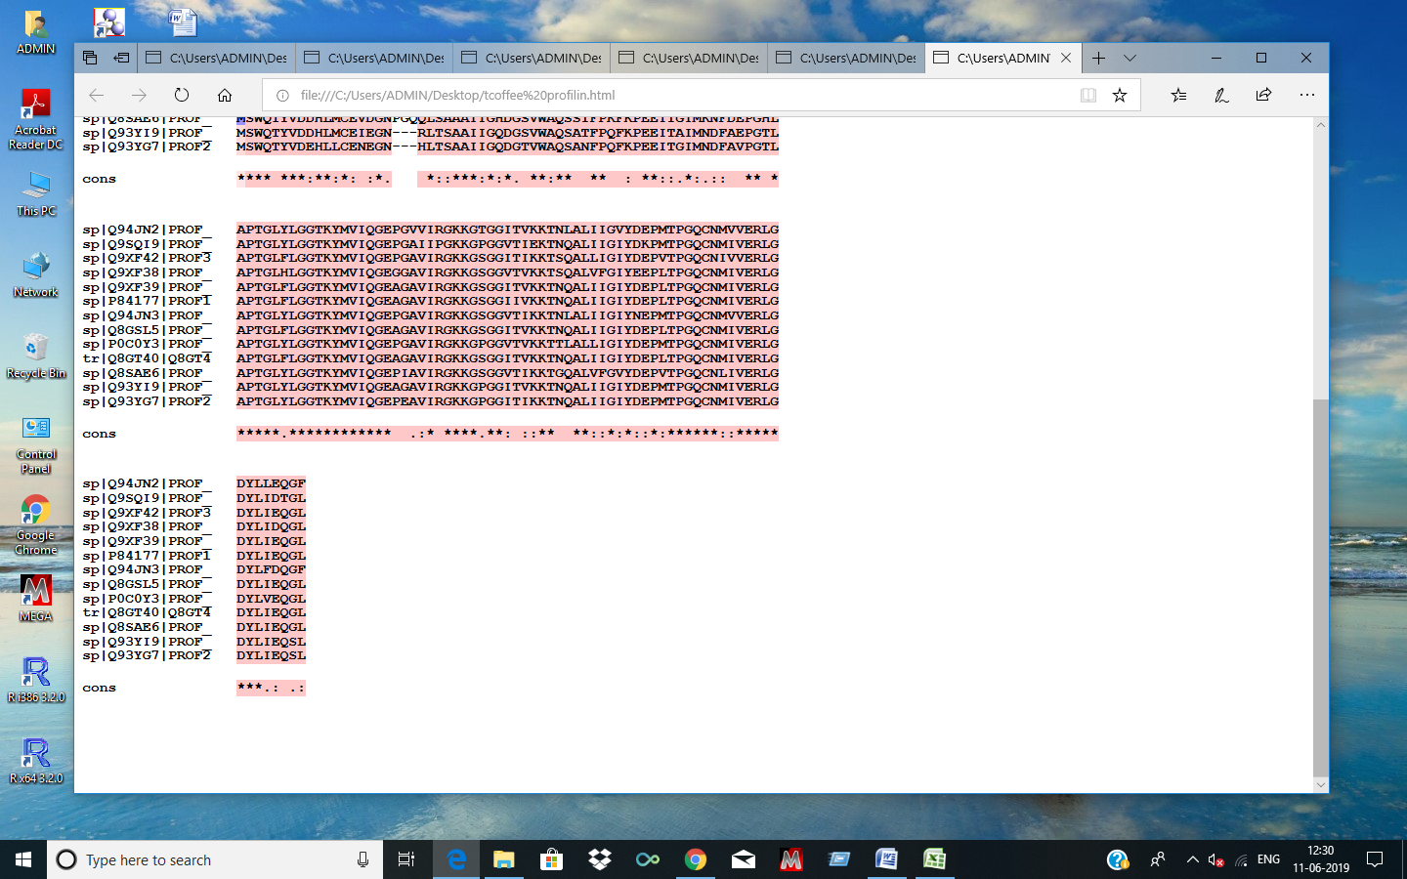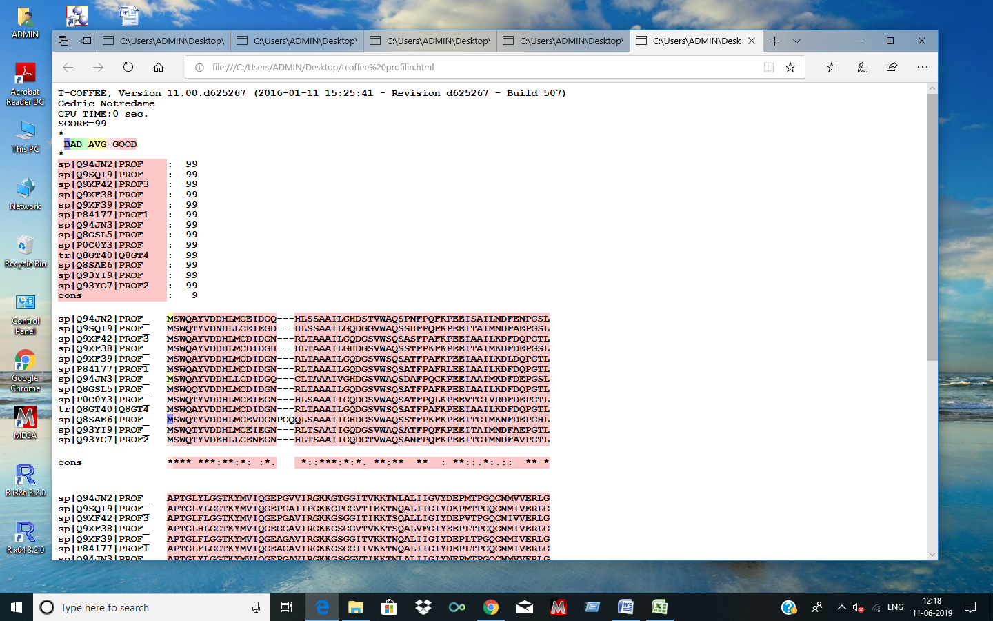

* **Epitope prediction in all food containing profilin was done as follows-**

|  |  |  |  |  |
| --- | --- | --- | --- | --- |
| **SOURCE NAME** | **ALLERGEN** | **EPITOPE** | **ABCpred**  **(SCORES)** | **Bcepred**  **(PROPERTIES)** |
| Pineapple | [Ana c 1](http://www.allergen.org/viewallergen.php?aid=43) | PQFKPEEISA | 0.90 | Accessibility, Polarity, Exposed Surface |
| IRGKKGTGG | 0.73 | Hydrophilicity, Accessibility, Flexibility, Polarity |
| Peanut | [Ara h 5](http://www.allergen.org/viewallergen.php?aid=81) | PQFKPEEITA | 0.95 | Accessibility, Polarity, Exposed Surface |
| PGKKGPGG | 0.92 | Hydrophilicity, Accessibility, Flexibility |
| Apple | Mal d 4 | IRGKKGSG | 0.82 | Hydrophilicity, Accessibility, Flexibility, Polarity |
| Pear | [Pyr c 4](http://www.allergen.org/viewallergen.php?aid=564) | FPKFKPEEITA | 0.86 | Accessibility, Polarity, Exposed Surface |
| MKDFDEPGS | 0.82 | Hydrophilicity, Accessibility, Polarity |
| IRGKKGSGGV | 0.76 | Hydrophilicity, Accessibility, Flexibility, Polarity |
| TVKKTSQ | 0.74 | Flexibility, Accessibility, Exposed Surface |
| Sweet cherry | Pru av 4 | IRGKKGSG | 0.75 | Hydrophilicity, Accessibility, Flexibility, Polarity |
| Sweet Orange | [Cit s 2](http://www.allergen.org/viewallergen.php?aid=211) | IRGKKGSG | 0.80 | Hydrophilicity, Accessibility, Flexibility, Polarity |

|  |  |  |  |  |
| --- | --- | --- | --- | --- |
| Banana | [Mus a 1](http://www.allergen.org/viewallergen.php?aid=445) | PQCKPEEI | 0.84 | Hydrophilicity, Accessibility, Exposed Surface, Polarity |
| MKDFDEPG | 0.82 | Hydrophilicity, Accessibility, Polarity |
| IRGKKGSG |  | Hydrophilicity, Accessibility, Flexibility, Polarity |
| Almond | [Pru du 4](http://www.allergen.org/viewallergen.php?aid=555) | IRGKKGS | 0.75 | Accessibility, Flexibility, Polarity |
| QYVDDHLMC | 0.87 | Accessibility, Polarity, Antigenic propensity |
| Strawberry | [Fra a 4](http://www.allergen.org/viewallergen.php?aid=330) | VRDFDEPG | 0.91 | Hydrophilicity, Accessibility, Polarity |
| IRGKKGPG | 0.74 | Hydrophilicity, Accessibility, Flexibility, Polarity |
| Peach | [Pru p 4](http://www.allergen.org/viewallergen.php?aid=559) | IRGKKGS | 0.75 | Hydrophilicity, Accessibility, Flexibility, Polarity |
| Carrot | [Dau c 4](http://www.allergen.org/viewallergen.php?aid=272) | VDDHLMCEVD | 0.83 | Accessibility, Polarity, Antigenic propensity |
| FPKFKPEEITG | 0.77 | Accessibility, Polarity, Exposed Surface |
| IRGKKGSG | 0.75 | Hydrophilicity, Flexibility, Accessibility, Polarity |
| Capsicum | [Cap a 2](http://www.allergen.org/viewallergen.php?aid=181) | PQFKPEEITA | 0.94 | Accessibility, Exposed Surface, Polarity |
| IRGKKGPG | 0.81 | Hydrophilicity, Accessibility, Flexibility, Polarity |
| Tomato | [Sola l 1](http://www.allergen.org/viewallergen.php?aid=422) | CENEGNHL | 0.68 | Hydrophilicity, Accessibility, Polarity |
| PQFKPEEITG | 0.81 | Accessibility, Exposed Surface, Polarity |
| EAVIRGKKGPG | 0.75 | Hydrophilicity, Flexibility, Accessibility , Polarity |

* **The result of secondary protein structure modeling along with epitope visualization in PyMOL.**

1. Pineapple

Selected epitope- PQFKPEEISA

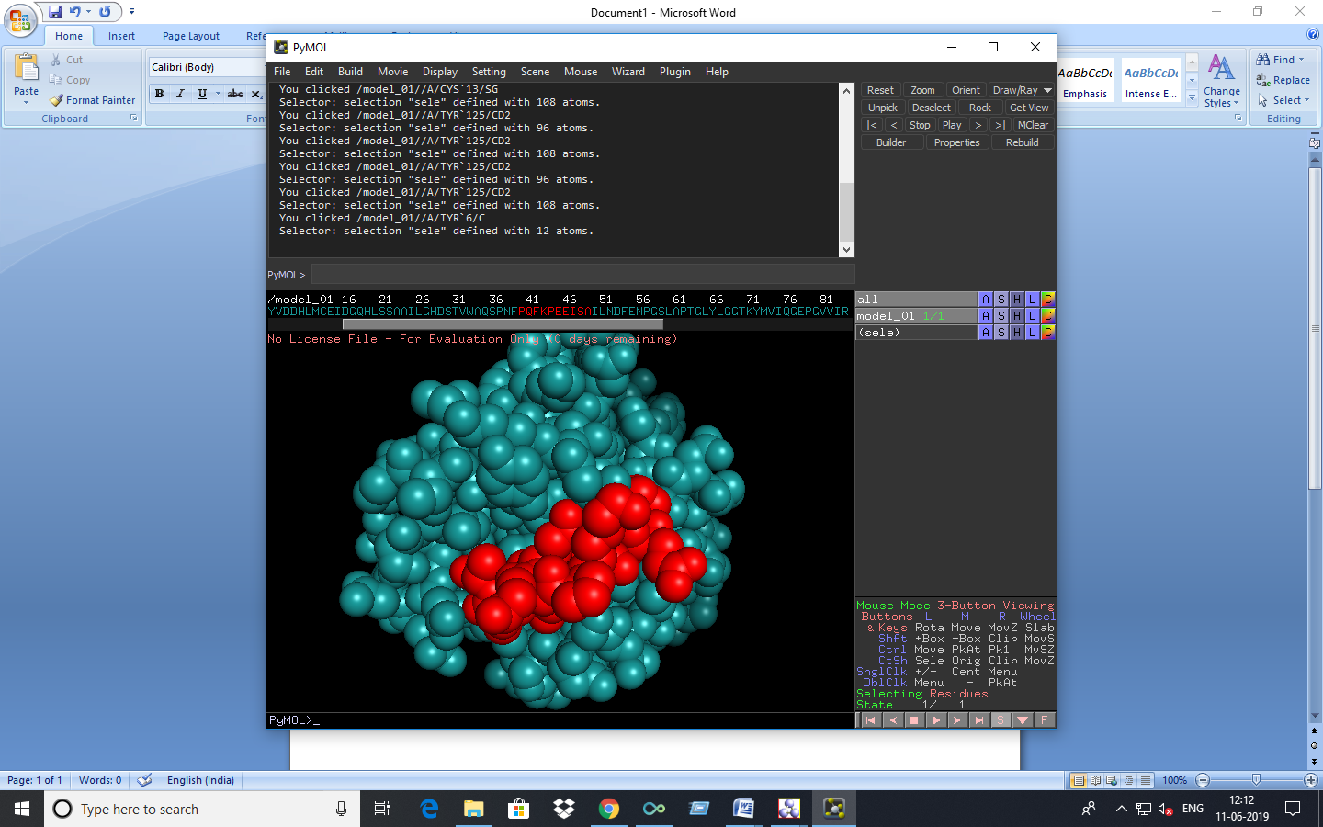

1. Peanut

Selected epitope- PGKKGPGG

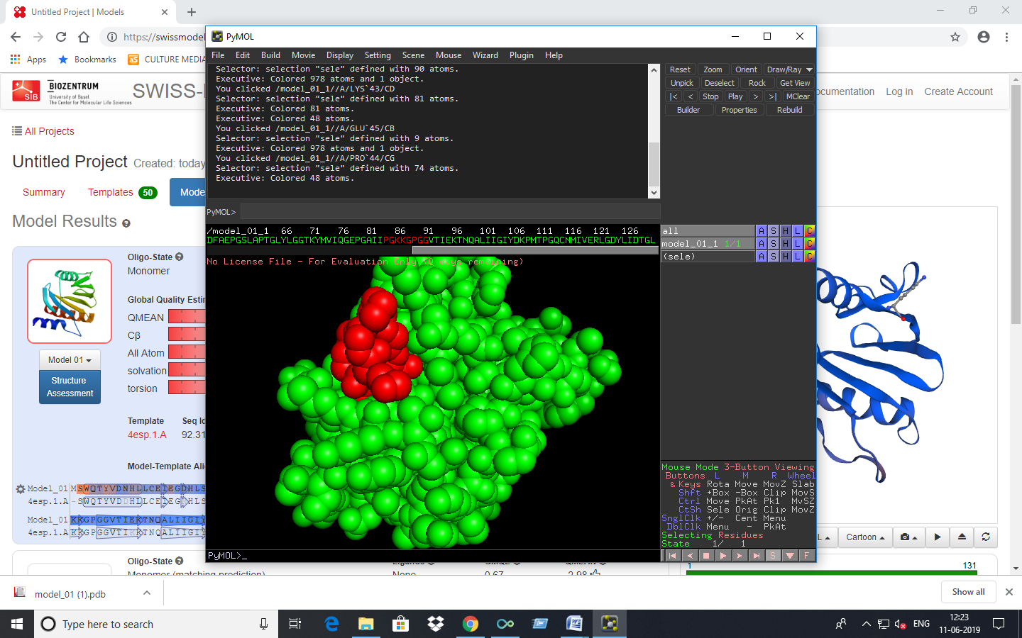

1. Pear

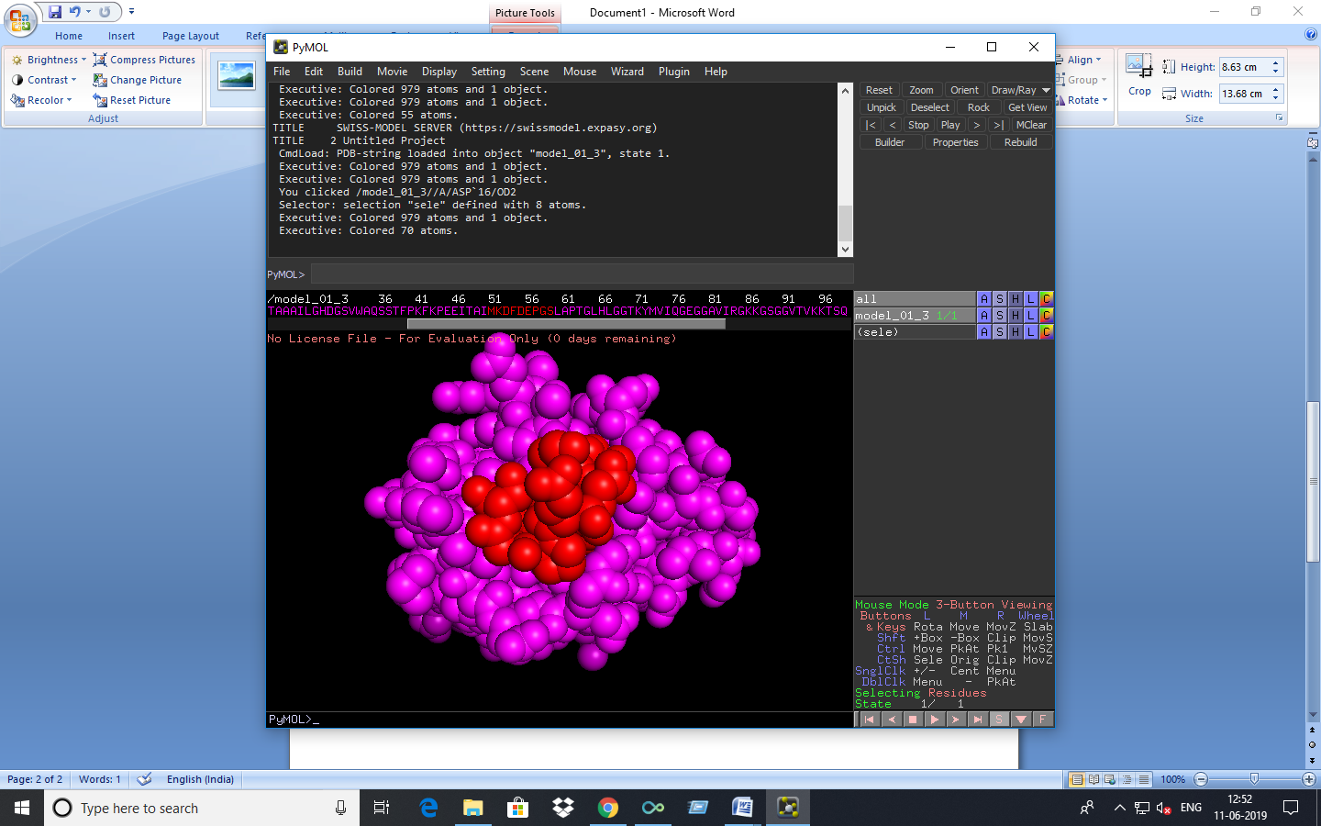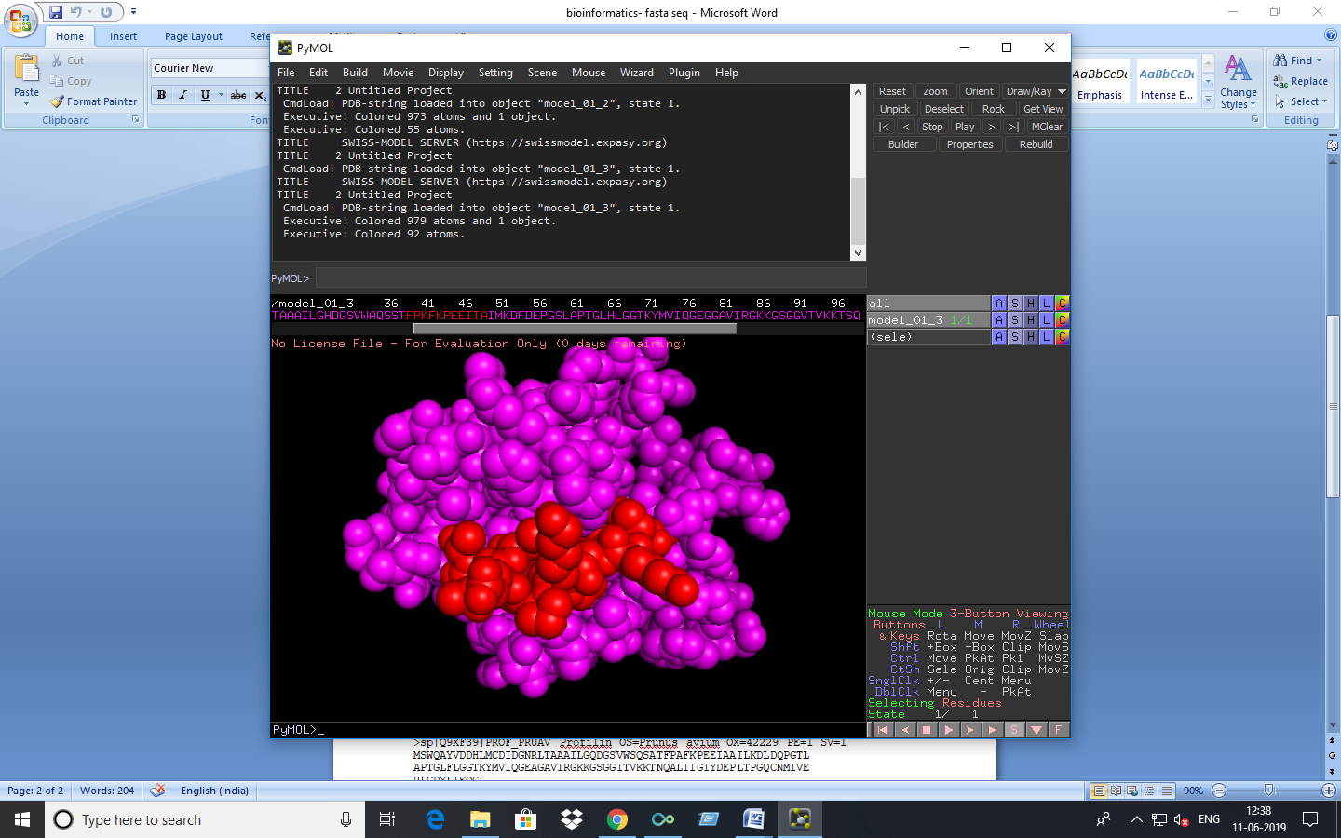Selected epitope- FPKFKPEEITA , MKDFDEPGS

1. Banana

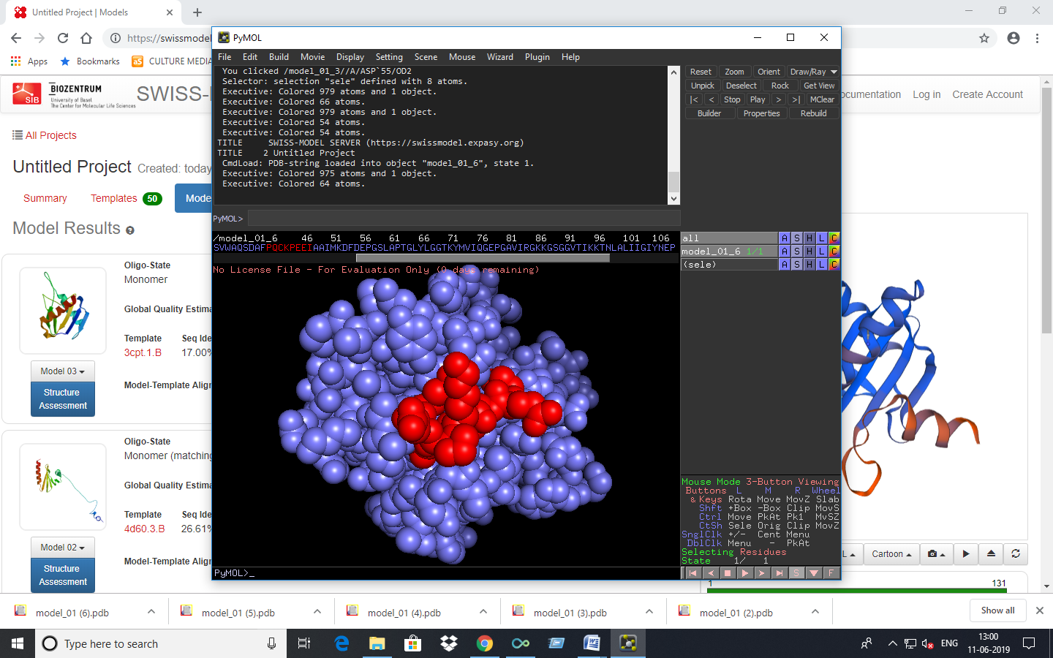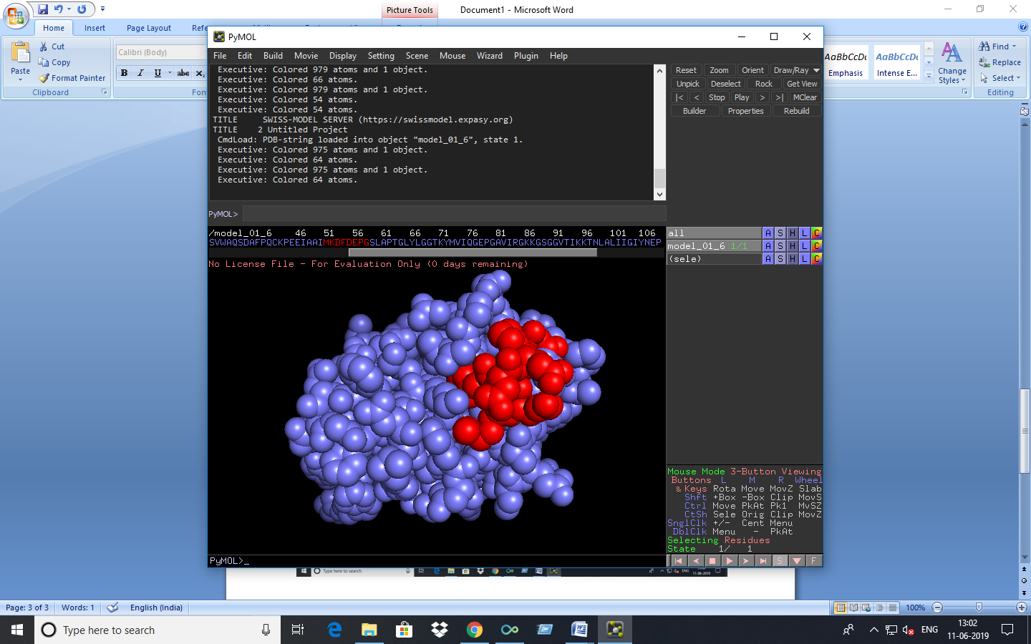Selected epitope- PQCKPEEI, MKDFDEPG

1. Almond

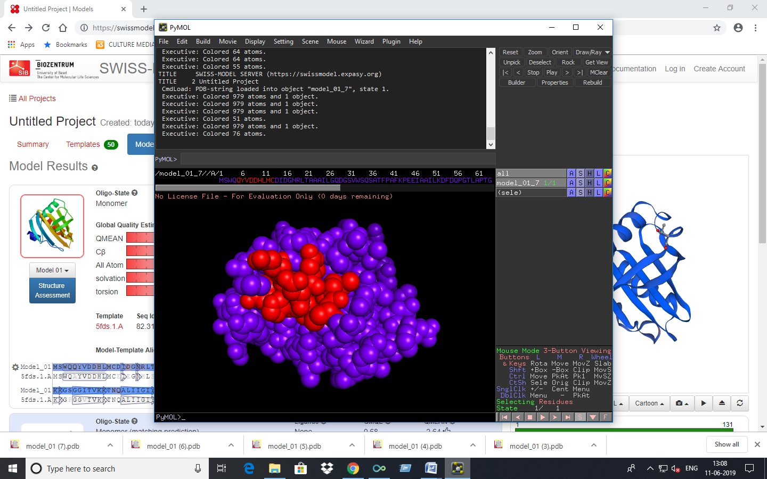Selected epitope- QIVDDHLMC

1. Strawberry

Selected epitope- VRDFDEPG

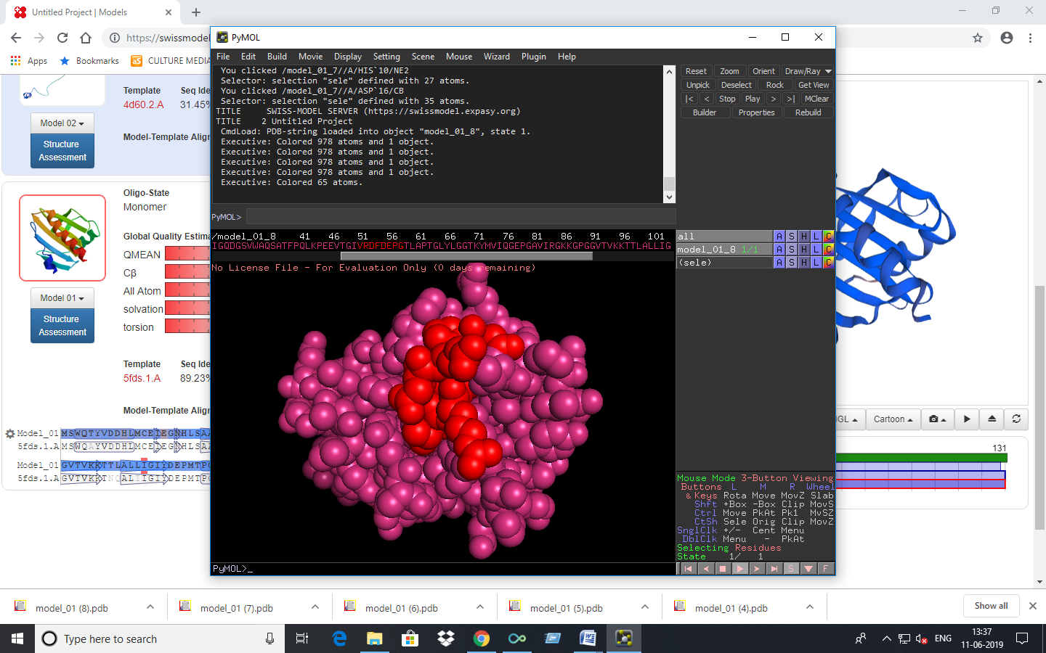7. Carrot

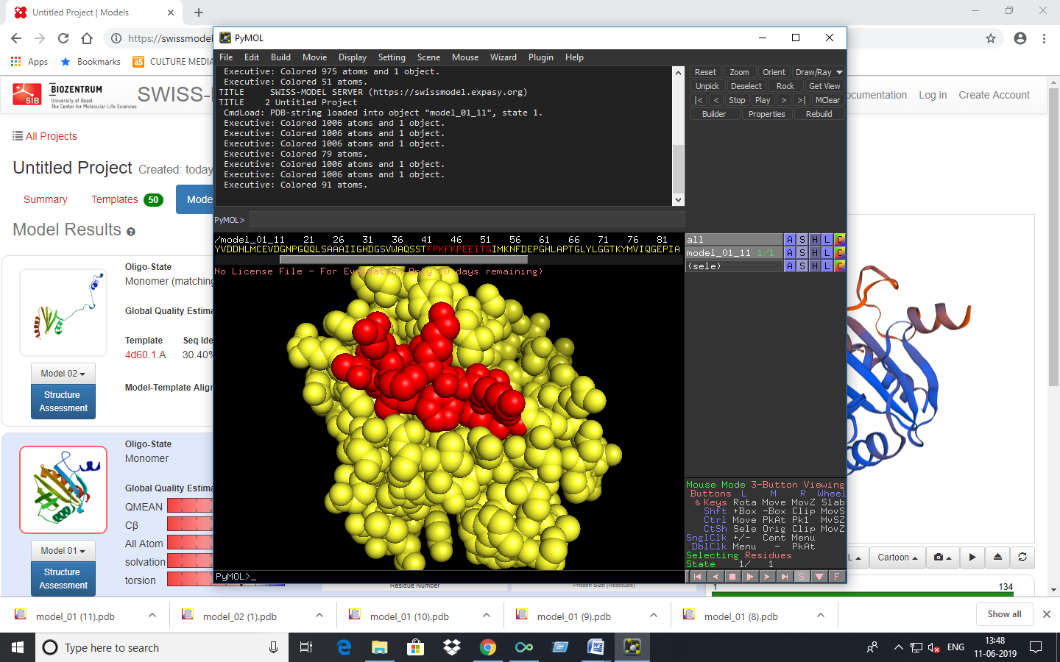 Selected epitope- FPKFKPEEITG

8. Capsicum

Selected epitope- PQFKPEEITA

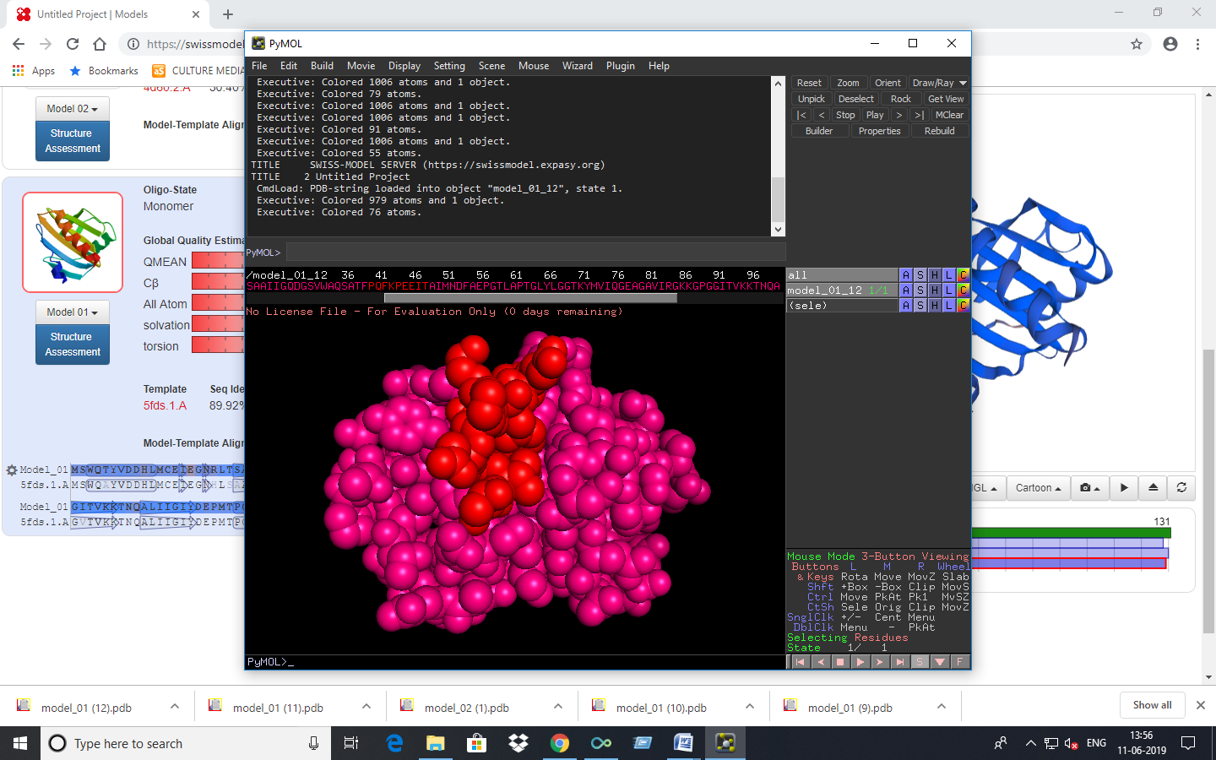

9. Tomato

Selected epitope- CENEGNHL, PQFKPEEITG

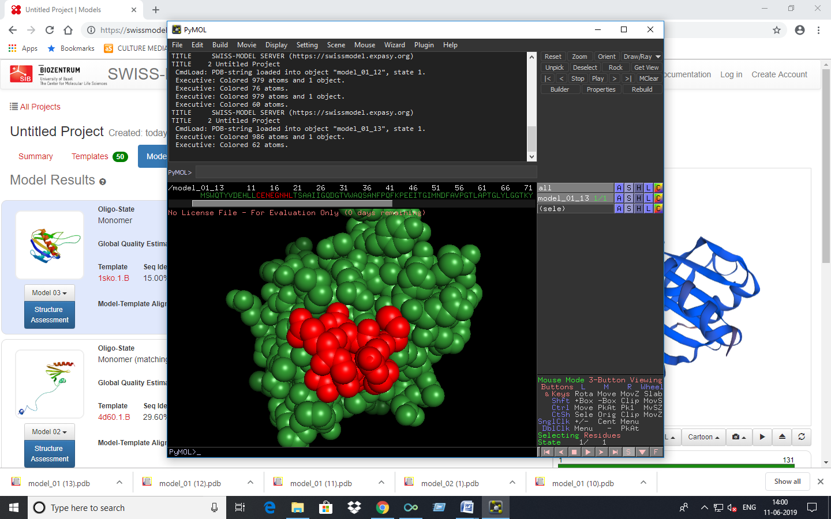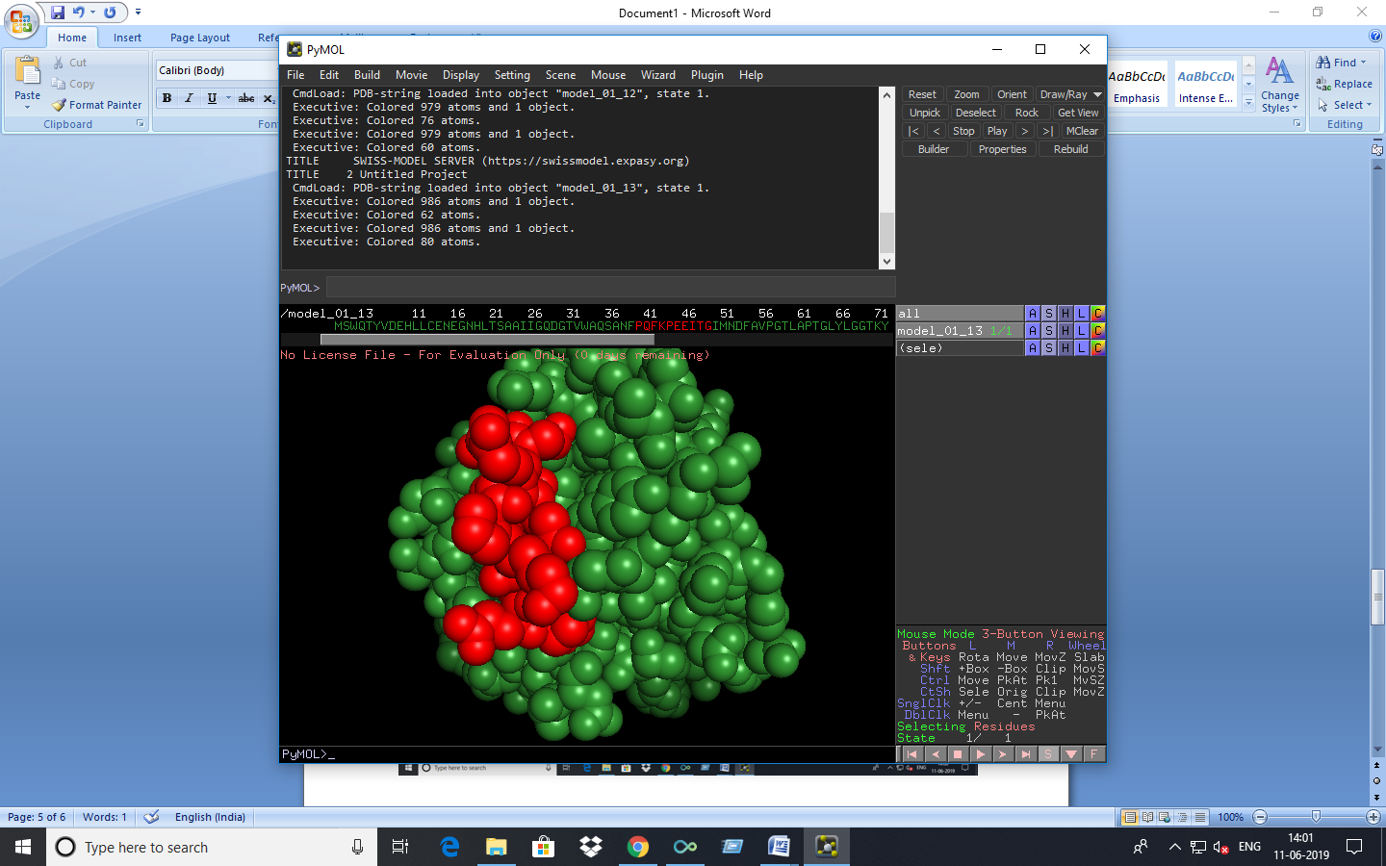

* **Discussion**

The data collected from Allfam database is compared with our chosen data and is represented in the graph to show the prevalence of the respected allergens. From the graph we selected profilin for rest of the work as its prevalence is maximum (except for Prolamin super family because it contains two allergens- nsLTP and 2S albumin) compared to others.

Multiple sequence alignment of profilin containing selected fruits and vegetables shows that they have a high level of similarity and contains conserved region- IRGKKGSG and FKPEEITG.

Then epitope prediction is done using ABCpred and Bcepred which shows possibility of being an epitope and their respective properties respectively.

Finally secondary structure prediction along with epitope is done and shown above.

**CONCLUSION**

Food as a trigger for allergic reactions is gaining more importance and up to 60% of food allergies in older children, adolescents and adults are linked with an inhalant allergen.

It can be observed that most fruits available in the market elicit allergic reactions in susceptible individuals. The prevalence of fruit allergy appears to result from the increased imports and exports of fruits sensitizing susceptible individuals. It can also be observed that similar allergens are present in most of the fruits, and show structural similarity with homologous allergens from pollens and other vegetables/fruits.

As epitope mapping of profilin of different fruits is done in this project it enables us to have an idea about the location of particular epitopes on the surface of these protein and that will in future help to prepare vaccines against these allergens and thereby help us to fight against the food allergies.

**REFERENCE**

**1**. Wang J, Sampson HA. Food allergy. J Clin Invest. 2011;121(3):827-35.

**2**. Kivity S. Adult-onset food allergy. Isr Med Assoc J. 2012;14(1):70-2.

**3**. Crespo JF, Rodriguez J. Food allergy in adulthood. Allergy. 2003;58(2):98-113.

**4**. Wang J. Oral allergy syndrome. In: Metcalfe DD, Sampson HA, Simon RA (Eds). Food Allergy: Adverse Reactions to Foods and Food Additives, 4th edn. Blackwell Publishing, Boston, 2008:133-43.

**5**. Breiteneder H, Radauer C. A classification of plant food allergens. J Allergy ClinImmunol. 2004;113(5):821-30.

**6**. Ballmer-Weber BK, Hoffmann-Sommergruber K. Molecular diagnosis of fruit and vegetable allergy. CurrOpin Allergy ClinImmunol. 2011;11(3):229-35.